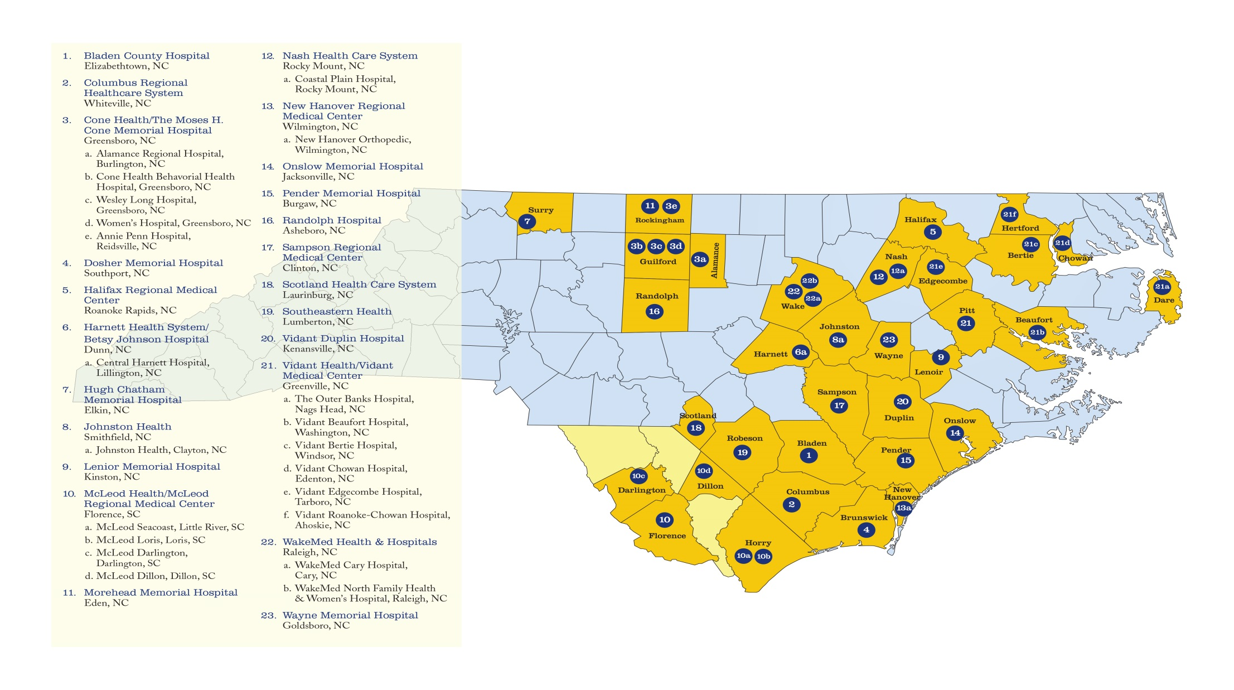
Mission: To provide a diverse portfolio of cost-saving opportunities through collaborative efforts and member engagement.
Vision: To be a dependable resource to our members by generating monetary savings, enhancing operational efficiencies and facilitating quality improvement.
Values: Collaborative, Integrity, Member-Centric, Reliable.
Representing: 23 hospital systems and 43 hospitals; 33 counties in North and South Carolina; over $6.8 billion in net patient revenues; 9,300 licensed beds

www.illucient.org

